[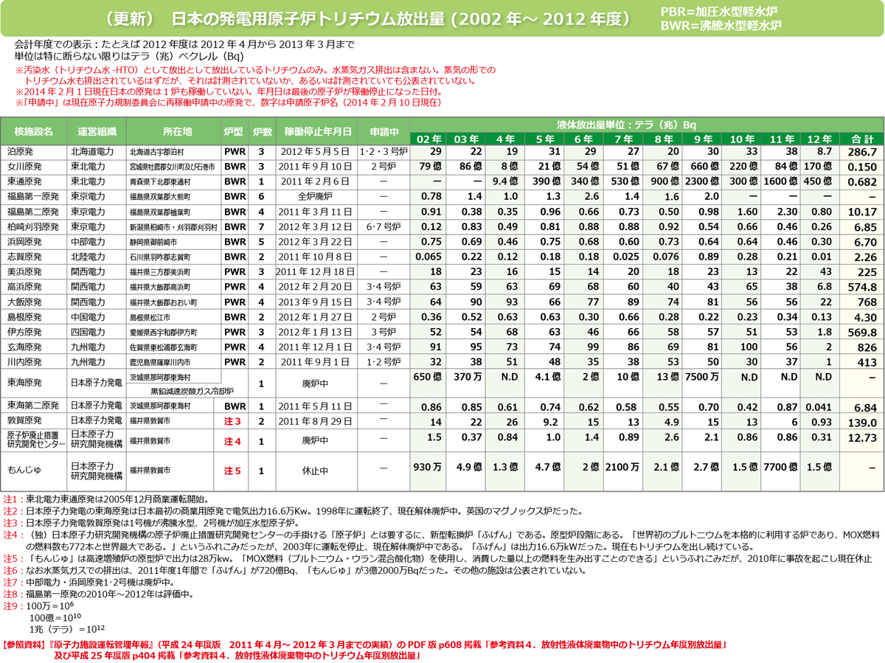](http://www.inaco.co.jp/isaac/shiryo/genpatsu/image/tricium_jp_2002-2012.jpg)